Implementing Predictive Analytics to Optimize Customer Churn Prediction
Activity_3_Data Cleaning & Exploratory Data Analysis (EDA)
1.Univariate Analysis:
Univariate analysis means analyzing one variable at a time, independently, without considering its relationship with any other variable.
Objective of Univariate Analysis
The main objectives are:
Understand the distribution of each variable
- How values are spread
- Are values concentrated or scattered?
- Is the data skewed (left/right)?
Identify common patterns and ranges
- Most frequent values
- Minimum and maximum values
- Typical customer behavior (e.g., short tenure vs long tenure)
Detect outliers or unusual values
- Very high charges
- Extremely long or short tenure
- Any abnormal patterns that may affect modeling
Understand customer characteristics (business view)
For example:
- Are most customers on month-to-month contracts?
- Are charges generally low or high?
- Is the dataset balanced by gender?
Prepare for deeper analysis (Bivariate & Modeling)
Univariate analysis helps us:
- Decide which features matter
- Decide which features need scaling
- Build intuition before analyzing churn relationships
🔹 Types of Univariate Analysis (Very Important)
🔸 For Numerical Variables (e.g., tenure, charges)
We use:
- Histograms → distribution
- Boxplots → spread & outliers
- Summary statistics (mean, min, max)
1. Objective of Univariate Analysis
Univariate analysis focuses on analyzing one variable at a time to understand its distribution, spread, and patterns within the dataset.
The objective of this step is to:
- Understand customer demographics and service usage
- Identify skewness, concentration, and outliers
- Prepare variables for further churn-focused (bivariate) analysis
2. Numerical Variable Analysis
2.1 Tenure (Customer Lifetime in Months)
Method Used: Histogram
Description:
Tenure represents the number of months a customer has stayed with the company.
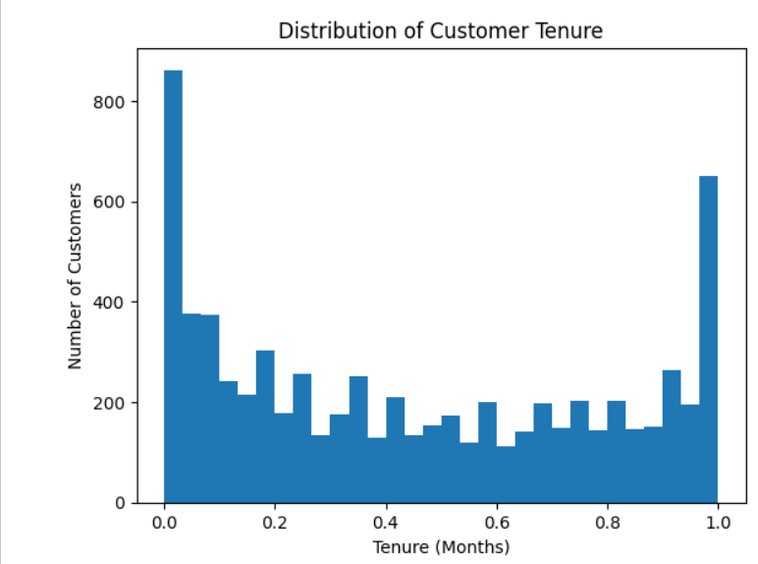
Observations:
- A large number of customers have low tenure, indicating many new customers
- Another concentration is observed near the maximum tenure (around 72 months), representing long-term loyal customers
- The distribution is right-skewed, with fewer customers in the mid-tenure range
Insight:
- Customers with shorter tenure may be more likely to churn
- Tenure is expected to be a strong churn indicator
2.2 Monthly Charges
Method Used: Histogram
Description:
MonthlyCharges indicates the amount a customer is billed monthly for services.
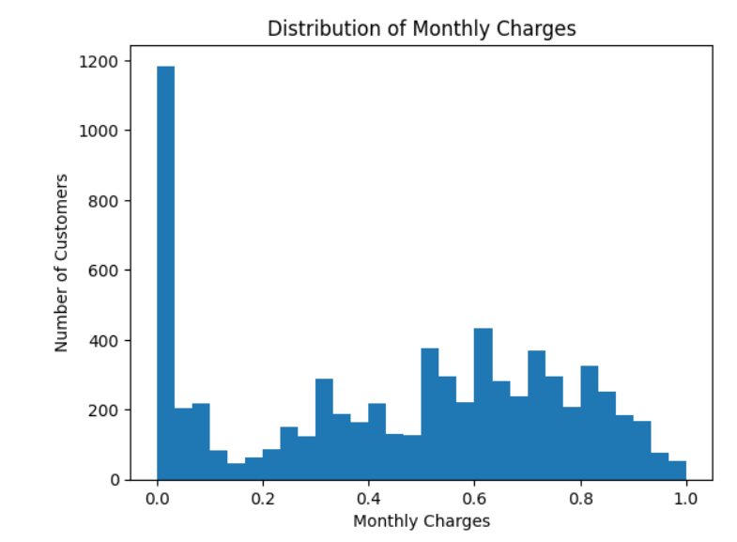
Observations:
- Charges are spread across a wide range
- A high concentration of customers exists at lower monthly charges
- Fewer customers fall into the high-charge range
Insight:
- Customers paying higher monthly charges may be more sensitive to pricing
- MonthlyCharges may influence churn behavior and should be further analyzed
2.3 Total Charges
Method Used: Histogram
Description:
TotalCharges represents the cumulative amount billed to a customer over time.
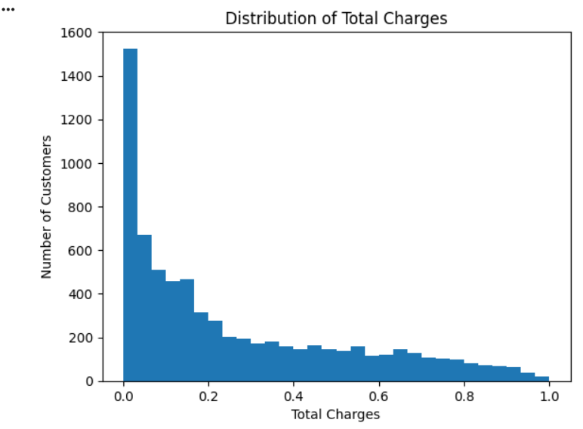
Observations:
- The distribution is highly right-skewed
- Many customers have low total charges, which aligns with customers having short tenure
- Customers with long tenure show higher total charges
Insight:
- TotalCharges is strongly linked with tenure
- Customers with low total charges are likely new and potentially at higher churn risk
3. Categorical Variable Analysis
3.1 Gender Distribution
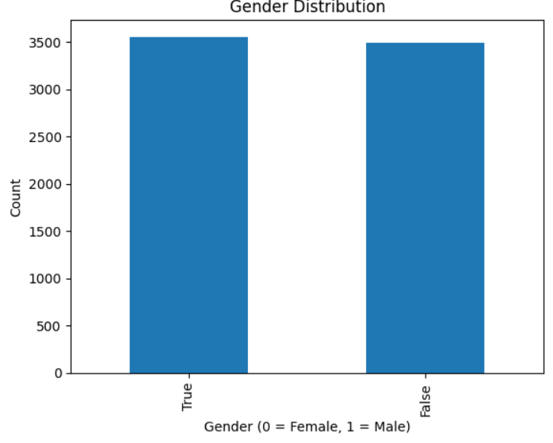
Method Used: Bar Chart

Description:
Gender was analyzed using the encoded variable (gender_Male).
Observations:
- The distribution of male and female customers is nearly balanced
- No significant dominance of one gender over the other
Insight:
- Gender alone may not be a strong predictor of churn
- Further analysis with churn is required to confirm impact
3.2 Contract Type Distribution
Method Used: Bar Chart
Description:
Contract types were reconstructed from encoded variables into:
- Month-to-Month
- One Year
- Two Year
Observations:
- Month-to-Month contracts form the largest customer group
- One-Year and Two-Year contracts have fewer customers
Insight:
- Customers on Month-to-Month contracts may show higher churn risk
- Contract type is expected to be a key churn-influencing variable
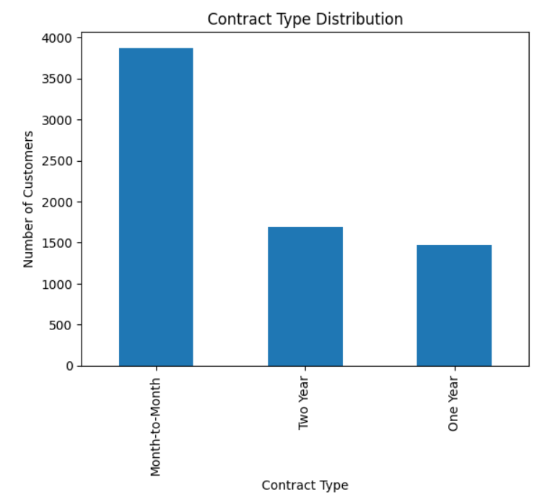
3.3 Payment Method
A bar chart was used to analyze the distribution of payment methods among customers.
Observation:
- Electronic Check is the most commonly used payment method.
- Mailed Check is the second most preferred option.
- Automatic payment methods (Credit Card and Bank Transfer) are used by fewer customers.

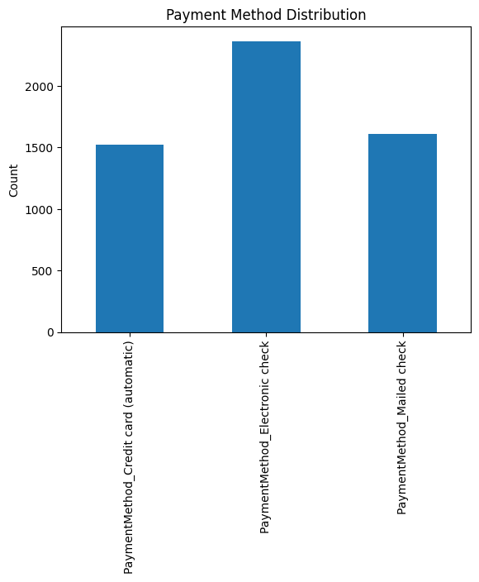
Insight:
Most customers prefer manual payment methods, which may indicate a higher likelihood of churn compared to customers using automatic payments.

2. Bivariate Analysis:
Objective of Bivariate Analysis
Bivariate analysis focuses on analyzing the relationship between two variables at a time, especially between customer churn and other customer attributes.
The main objectives are:
- Understand how different customer features influence churn
- Identify patterns associated with higher or lower churn rates
- Support feature selection for predictive modeling
- Convert univariate insights into actionable churn drivers
In this analysis, Churn is treated as the target variable and is compared with key demographic, service, and billing variables.
Prepare Churn column
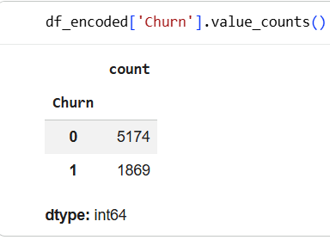

2.1 Churn vs Gender
Method Used:
Normalized Bar Chart (Proportion)
Description:
This analysis compares churn behavior between male and female customers using the encoded gender variable.
Observations:
- The churn proportion is nearly similar for both genders
- No significant difference is observed in churn behavior between males and females
Insight:
- Gender does not appear to have a strong influence on churn
- Gender may not be a key predictor for churn modeling
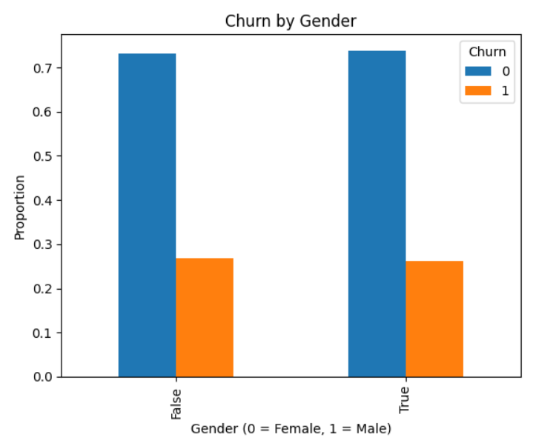
2.2 Churn vs Contract Type
Method Used:
Normalized Bar Chart
Description:
Churn was analyzed across different contract types:
- Month-to-Month
- One Year
- Two Year
Observations:
- Month-to-Month customers show the highest churn rate
- One-Year contract customers have a lower churn rate
- Two-Year contract customers show the lowest churn rate
Insight:
- Short-term contracts are strongly associated with higher churn
- Long-term contracts significantly improve customer retention
- Contract type is a critical churn-influencing factor
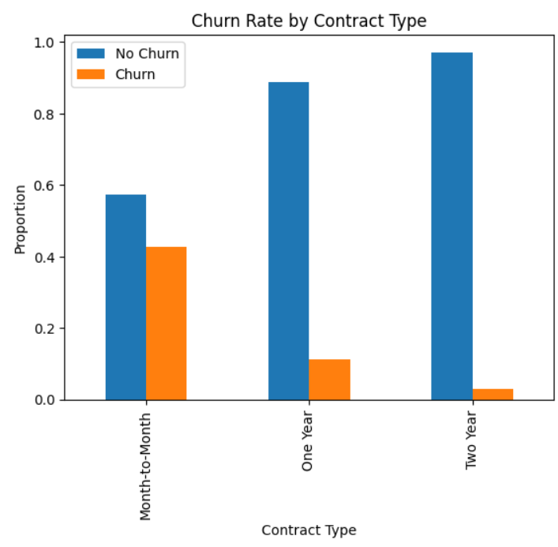
2.3 Churn vs Payment Method
Method Used:
Normalized Bar Chart
Description:
This analysis examines churn behavior across different payment methods:
- Electronic Check
- Mailed Check
- Credit Card (automatic)
- Bank Transfer (automatic)
Observations:
- Customers using Electronic Check have the highest churn rate
- Mailed Check users show moderate churn
- Customers using automatic payment methods have the lowest churn rates
Insight:
- Manual payment methods are associated with higher churn
- Automatic payment methods help reduce churn risk
- Encouraging auto-payments may improve customer retention

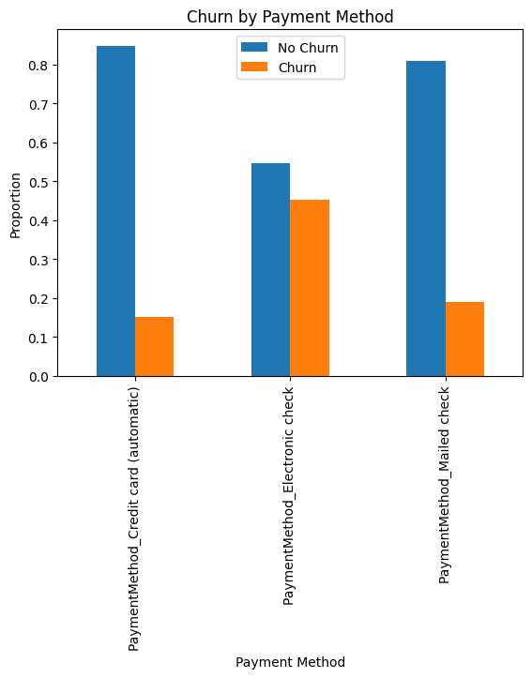

2.4 Churn vs Monthly Charges
Method Used:
Box Plot
Description:
Monthly Charges were compared between churned and non-churned customers to understand pricing impact.
Observations:
- Churned customers generally have higher monthly charges
- Non-churned customers tend to fall in the lower charge range
- Presence of higher charge outliers among churned customers
Insight:
- Higher monthly charges may contribute to customer dissatisfaction
- Pricing plays an important role in churn behavior
- MonthlyCharges is an important numerical predictor for churn
- <Figure size 640x480 with 0 Axes>
- 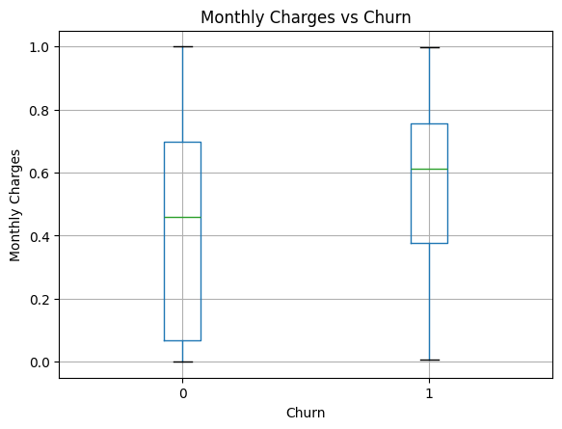

2.5 Churn vs Tenure
Method Used:
Box Plot / Distribution Comparison
Description:
This analysis compares customer tenure between churned and retained customers.
Observations:
- Customers with shorter tenure have a higher churn rate
- Long-tenure customers are more likely to stay with the company
- Churn is concentrated among newer customers
Insight:
- Tenure is one of the strongest indicators of churn
- Early customer engagement is critical for retention
- Retention strategies should focus on new customers
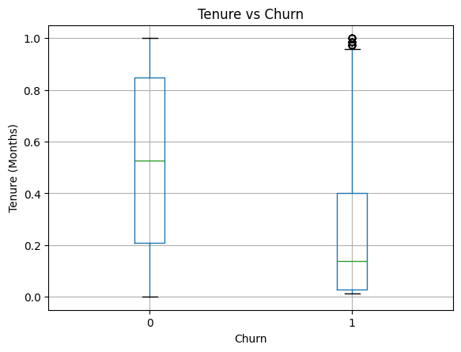
2.6 Summary of Bivariate Analysis
Key findings from bivariate analysis:
- Contract type and payment method have a strong relationship with churn
- Customers on month-to-month contracts are most likely to churn
- Manual payment methods show higher churn compared to automatic payments
- Higher monthly charges increase churn likelihood
- Short-tenure customers are at greater churn risk
- Gender has minimal impact on churn
These insights provide a strong foundation for predictive modeling and churn prevention strategies.

